MAKING ELECTIONS MAKE SENSE

Send a message. Vote!
California Primary Election, June 6, 2006

YOUR QUICK GUIDE TO:
• The Election
• The Candidates
• The Propositions

• How Voting Works

This FREE guide is available in English, Spanish, Chinese, Vietnamese and Korean.
VISIT WWW.EASYVOTER.ORG for copies and voting information in these languages.
The nonpartisan Easy Voter Guide Project is a collaboration of the California Secretary of State’s Office, the League of Women Voters of California Education Fund and the California State Library, with additional support from The James Irvine Foundation and the San Francisco Foundation.

About This Election
California has seven political parties. The purpose of the June 6, 2006 Primary Election is to let voters choose which candidates they want to represent their political party for each elected office. The winners of the June Primary Election for each party then run against each other in the November General Election.
This guide covers statewide candidates and two propositions that could change state law. Your ballot may also have local races and local ballot measures. You do not have to vote on everything. Choose what you want to learn more about and vote on that.

What is new this election?

- There is a new law that requires you to provide identification when you register to vote. Be sure to include your identification information on the registration form. Fill out the form completely and correctly, or there may be delays in getting your name on the list of voters.
- If you are a first-time voter, you may have to show identification if you registered to vote by mail.
- Many counties will have new voting equipment. Check with your county registrar or at www.easyvoter.org to find out if you will be voting a new way.

About the Political Parties

When you sign up to vote, you will be asked if you want to join a political party. A political party is a group of people who share the same ideas about what government should do. They work together to try to win elections. There is no cost to join a party. You can also choose not to join a party by marking “decline to state” on the voter registration form. If you want to change your party, fill out a new registration form.
Your party choice affects what kind of ballot you will get in this Primary Election:
• If you are registered with a political party, your ballot will only have candidates from your party for partisan offices.
• If you registered “decline to state” (not with a party), you have a choice of ballots in this election. You can ask for one of these parties’ ballots: American Independent, Democrat or Republican. Or, you will get a “nonpartisan” ballot with no candidates listed for partisan offices.
Some of the partisan offices in this election are Governor,
U. S. Senator, U.S. Congressperson, State Senator and State Assemblyperson. Nonpartisan offices include the State Superintendent of Public Instruction and local officials.
All ballots will have nonpartisan offices and ballot measures.
Everything on your ballot will be listed in the Sample Ballot mailed by your county elections office.

For more nonpartisan information about this election, visit these websites:
www.easyvoter.org
User-friendly information in five languages for new and busy voters.
www.smartvoter.org
Look up your personal ballot and polling place.
www.ss.ca.gov/elections
In-depth Voter Information Guide in different languages.

Key Dates
• May 22, 2006 is the deadline to register to vote in this election. You need to re-register if you have moved.
• If you want to vote by mail (with an “absentee ballot”), your county elections office needs your written request
by May 30.
• See back cover for more voting information.
Political Parties
There are seven parties in California. We asked each one what they stand for. You can use what the parties say to help you decide which one to join. Or, you can mark “decline to state” on your voter registration form if you do not want to join a party.

AMERICAN INDEPENDENT
The American Independent Party stands for constitutional government and safeguarding the liberties of individual citizens. It believes government should protect innocent human life and uphold traditional moral values. It would end outsourcing of American jobs.
• End illegal immigration
• Balance the state budget
• Address levee repairs/state water problems
311,000 members in California*
619-460-4484
www.aipca.org

DEMOCRATIC
The Democratic Party stands for working families, affordable health care, a woman’s right to choose and a cleaner environment. This party believes the role of government is to protect individual rights while ensuring a stable and prosperous nation.
• Quality education, especially full access to higher education
• Economic stability
• Safe communities
311,000 members in California*
619-460-4484
www.aipca.org

GREEN

The Green Party stands for social and economic justice, nonviolence, respect for diversity and protection of the environment. This party believes the role of government is to represent the people and protect the environment.

• A living wage, health care and education for all

• Clean energy and environmental protection

• Election reform

146,000 members in California*

916-448-3437

www.cagreens.org

LIBERTARIAN
The Libertarian Party is as American as apple pie. If you describe yourself as socially tolerant and fiscally responsible, you’re a Libertarian. This party believes you, not the government, should decide how to run your life, checkbook, education and family.
• Keep what you earn; reduce taxes whenever possible
• Educate your children as you see fit
• Safe streets
83,000 members in California*
1-877-884-1776
www.ca.lp.org

NATURAL LAW
The Natural Law Party stands for problem-solving that is in tune with the natural movement of life,
i.e. meditation as an alternative to war. This party believes that government is here to serve the people and not the other way around.
• An alternative to the two-party system
• Educate people about the real issues
• Involve common citizens in running the country
24,000 members in California*
760-888-9600
www.natural-law.org

PEACE & FREEDOM
The Peace and Freedom Party stands for a truly democratic society. Everyone should enjoy the wealth we all create. This party believes the role of government is to make sure that everyone has jobs, housing, education, health care and equal rights.
• Bring all troops home now
• Double the minimum wage
• One system of free, quality health care for all
59,000 members in California*
510-465-9414
www.peaceandfreedom.org

REPUBLICAN
The Republican Party stands for helping every Californian realize the American Dream. This party believes the role of government is to provide a safe and secure environment so
that families and businesses can flourish.
• Quality education for all children
• Help businesses create jobs and economic growth
• Protect children from predators
5,483,000 members in California*
818-841-5210
www.cagop.org

*The number of members for each party is as of 1/3/2006, rounded to the nearest thousand. There were also 2.9 million voters registered “decline to state.”

Candidates for Governor
The top boss in California • Elected for 4 years

• Oversees most state departments and agencies
• Approves or rejects new state laws
• Presents an annual budget to the State Legislature
• Appoints judges and department heads
• Manages state resources during emergencies

We asked each candidate for a short statement and their priorities. Candidates are listed alphabetically within each party. The parties are listed in the order of their size in California.

CANDIDATES

DEMOCRATIC
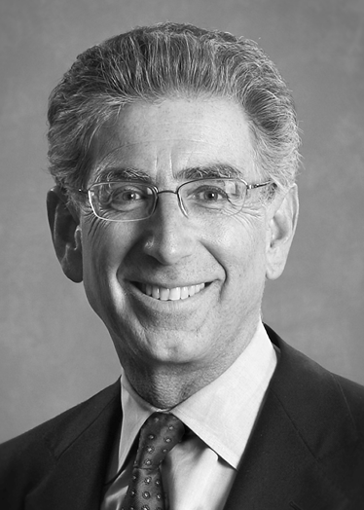
Phil Angelides
Occupation: State Treasurer
Age: 52 • Lives in: Sacramento
I have created my own business, met a payroll, and built environmentally sustainable communities. In eight years as Treasurer, I have cracked down on corporate fraud,
fought for balanced budgets, and invested to create jobs and clean up the environment.

Priorities:
• Invest to give all our children a first-class education.
• Enact fair, balanced budgets that protect schools and transportation.
• Protect our quality of life to make California the best place to create jobs.

www.angelides.com

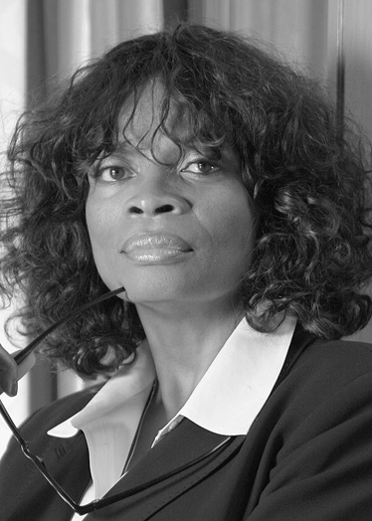
Barbara Becnel

Occupation: Executive Director, Nonprofit
Age: 55 • Lives in: Pleasant Hill
I have public policy, legislative and community program experience. I worked for nearly 20 years as a public policy expert in Washington, D.C. and Los Angeles. Currently, I oversee numerous social programs at a nonprofit agency in the Bay Area.

Priorities:
• Improve California’s public education system so that all children have an opportunity to achieve at high levels.
• Ensure quality and affordable healthcare for all Californians.
• Remove race and class bias from California’s criminal justice system.
www.VoteBarbaraBecnel-Gov.com

Joe Brouillette
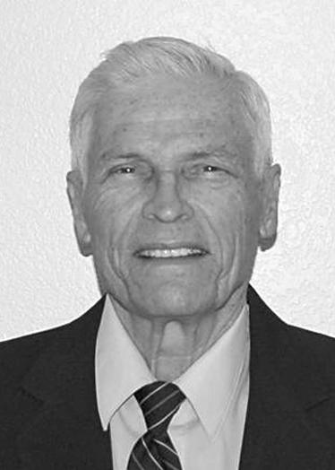
Occupation: High School Teacher

Age: 74 • Lives in: Granite Bay
I have taught social science classes for 44 years which includes U.S. and California government. I have a Masters Degree in Chico and a Masters of Science Degree from the University of Illinois.

Priorities:
• California’s overpopulation crisis is my main concern. From 6 million in 1940, to 36 million today and 64 million by 2050 unless action is taken through educating every Californian.
• Teach more government to empower voters.
www.oldjoeforgovernor.com

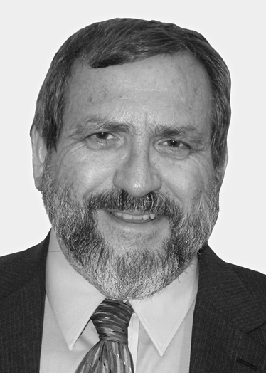
Jerald Robert Gerst

Occupation: Medical Doctor, Physician

Age: 59 • Lives in: Walnut Creek

Born in Iowa, raised on my family’s farm, I graduated from Harvard, obtaining my MD from UC Davis and my Master’s in Public Health from UC Berkeley. I have cared for working folks over three decades as an emergency and occupational physician.

Priorities:

• Balanced budgets – on time.

• Universal, population-based health insurance, kept cost-neutral to business by other insurance reforms.

• Balanced funding of infrastructure spending; debt alone compromises our children’s future.

Vibert Greene

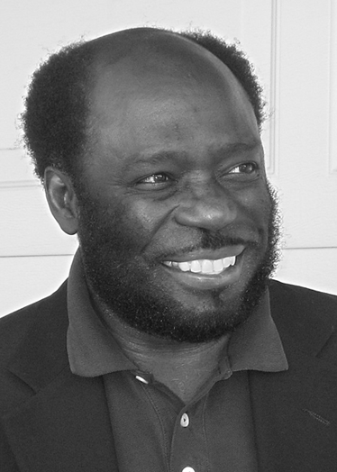
Occupation: Mechanical Engineer

Age: 57 • Lives in: Newark

Leadership, management and common sense. I say what I mean and mean what I say. I will deliver.

Priorities:

• Charge a tax to businesses that outsource jobs overseas.

• Give tax incentives to businesses that hire new employees.

• Increase salaries and benefits to state workers, teachers, fire, police and protect the environment.

Frank A. Macaluso, Jr.
Occupation: Physician/Medical Doctor
Age: 47 • Lives in: Exeter
I’m a small business owner with experience to deal with oil consumption and conservation. As a doctor, I can bring workable solutions to California’s health care system. I’m a strong advocate of health care for seniors and the uninsured.

Priorities:
• Budget - A balanced budget that does not spend more than the state takes in.
• Health care - All Californians have adequate and affordable health care.
• Immigration reform - Move forward now.
www.mac4gov.com

Michael Strimling
Occupation: Attorney at Law

Age: 52 • Lives in: Piedmont
Born in California, graduate of UC Berkeley Law, dedicated progressive, against the war and wiretaps. I have worked for courts, litigated for public agencies, and against toxic polluters. Legal advisor in the Peace Corps. A qualified lawyer, not actor.

Priorities:
• Universal healthcare, education, transit, childcare and eldercare.
• Schools and jobs, not jails: moratorium on capital punishment and expensive prisons.
• Tax corporations at real value of property, not at low Proposition 13 rates.
www.MichaelStrimling.com

Steve Westly

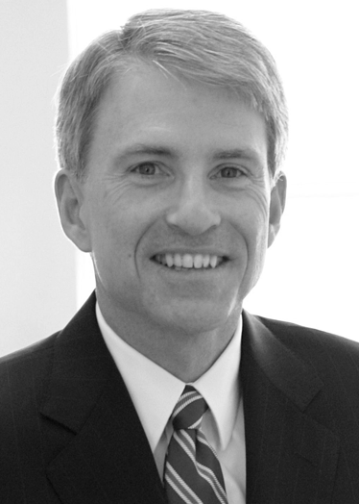
Occupation: California State Controller
Age: 49 • Lives in: Atherton
I helped build eBay, a company that created thousands of jobs. I taught at Stanford for five years. As Controller, I clamped down on corporate tax cheats, bringing in $3.5 billion for schools, roads, and hospitals without raising taxes.

Priorities:
• Better funds for education so our children have the opportunity to succeed.
• Defend the environment and push for affordable healthcare.
• Help create good-paying jobs for all Californians.
www.westly2006.com

REPUBLICAN

Jeffrey R. Burns

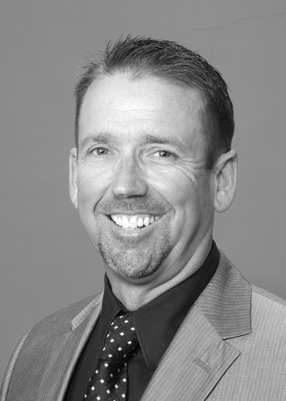
Occupation: General Building Contractor
Age: 51 • Lives in: Huntington Beach
My 31 years in the building industry has taught me more than anything else that a good businessman keeps one eye on today and the other on tomorrow. All state government decisions must be weighed against tomorrow.

Priorities:
• Budgetary models required by the retirement of 78 million baby boomers.
• Coordination of emergency services for statewide disaster or terror attack.
• A national immigration policy that will meet the needs of a 21st century economy.

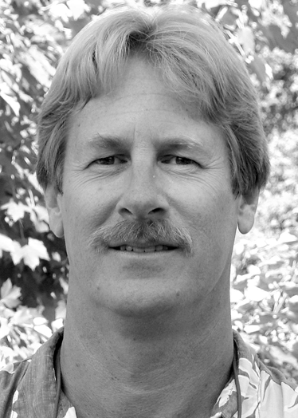
Bill Chambers

Occupation: Railroad Switchman/Brakeman

Age: 50 • Lives in: Auburn

I am a U.S. citizen, resident of California, registered Republican voter, taxpayer, railroad switchman/brakeman (29 years), real estate investor, landlord, occasional real estate developer (small scale), parent and grandparent. I use logic and common sense, not hype and emotion.

Priorities:

• To be completely open with the public and the media (state/national security issues excluded).

• To keep within our budget and reduce, if not eliminate, pork barrel spending.

• To find solutions to our schools’ constant problems.

www.billchambers4governor.com

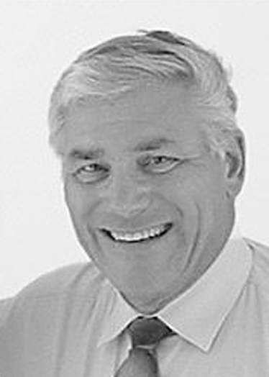
Robert C. Newman II

Occupation: Psychologist/Farmer

Age: 62 • Lives in: Redlands

I am your servant, a Bible-based 45-year married Christian, with education (AA, BA, MA, PhD) and work experience only in California, manual labor, then psychologist with experience in prison, state hospital, education, police and fire, and workers’ compensation systems.

Priorities:

• Answers: I think outside the box coming up with commonsense solutions.

• Education: Let teachers teach by increasing pupil contact; reduce forms and testing.

• Budget: Live within our means by reducing overspending; increase inter-party cooperation.
www.newman4governor.org

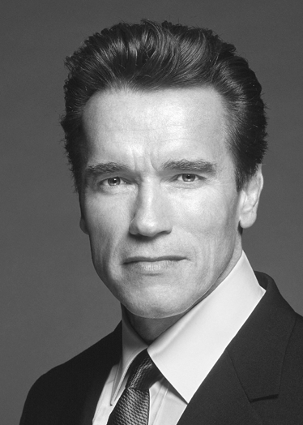
Arnold Schwarzenegger

Occupation: Governor of California

Age: 58 • Lives in: Los Angeles

As Governor I have led California back from the brink of bankruptcy by not raising taxes, reducing the structural deficit, repealing the car tax, and fixing workers’ compensation. The result: 500,000 new jobs and record investments in education.

Priorities:

• Strengthen California’s schools so our students are prepared for tomorrow.

• Strengthen and build California’s economy to create jobs.

• Protect California’s families with strong laws to protect our children.

www.joinarnold.com

AMERICAN INDEPENDENT

Edward C. Noonan

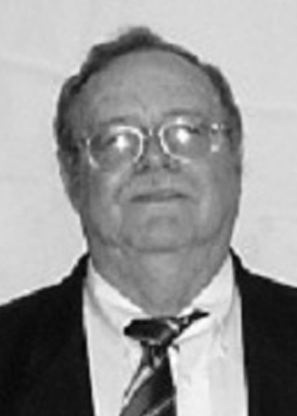
Occupation: Computer Shop Owner

Age: 58 • Lives in: Marysville

I am qualified to slow down the increased legislation that over-regulates businesses and overtaxes citizens. When I am in office I will use the veto pen as a tool to quell any further hardships to Californians.

Priorities:

• Cause a 2/3 majority for any new legislation to be placed on the backs of Californians. All new legislation will be vetoed.

• All budgets will be vetoed for debt reduction.

• Illegal immigration must stop.
www.ednoonan4gov.org

GREEN

Peter Miguel Camejo
Occupation: Financial Advisor

Age: 66 • Lives in: Folsom

I stand for the people of California, not just the rich. I work to defend the environment and have knowledge and experience with budget issues, pensions and developing affordable housing. I oppose the death penalty and “three strikes” law.

Priorities:

• Education: California spends 600 dollars less per student than the national average; it can be 600 dollars more.

• Alternative Energy: We need to start now.

• Free elections in California: IRV and proportional representation.
www.votecamejo.com

LIBERTARIAN

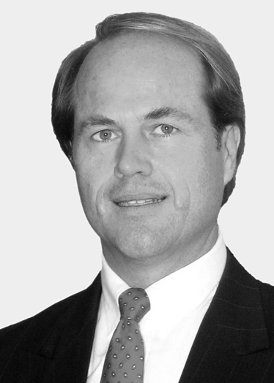
Art Olivier
Occupation: Former Mayor/ Engineer

Age: 48 • Lives in: Bellflower
California needs a governor that can say NO to wasteful spending. As the mayor of Bellflower, I was able to eliminate the city’s lighting tax assessment and at the same time improve services through privatization and a competitive bidding process.

Priorities:
• Reduce spending and taxes.
• Allow power plants to be built to avoid future blackouts.
• Use all gasoline taxes, vehicle license fees and sales tax on automobiles for road construction and maintenance to end gridlock.
www.electArt.com

PEACE AND FREEDOM

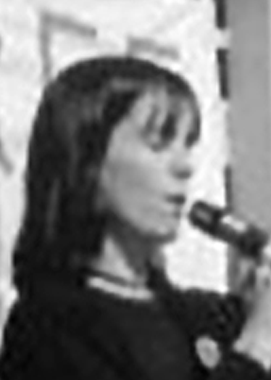
Janice Jordan
Occupation: Counselor, Activist, Grappler
Age: 41 • Lives in: San Diego
I was born and raised in California. My passion for social and political issues is to affect positive change in all communities.

Priorities:
• Healthcare.
• Livable wage.
• Immigrant rights.
www.janicejordan.org

Candidates for U.S. Senate
Our voice in Washington D.C.
Elected for 6 years
• One of two U.S. Senators that represents the people of California in Washington D.C.
• Works with U.S. Senators from other states to make new U.S. laws
• As a member of Congress, helps shape the budget and priorities for national government
We asked each candidate for a short statement and their priorities. Candidates are listed alphabetically within each party. The parties are listed in the order of their size in California.

CANDIDATES

DEMOCRATIC
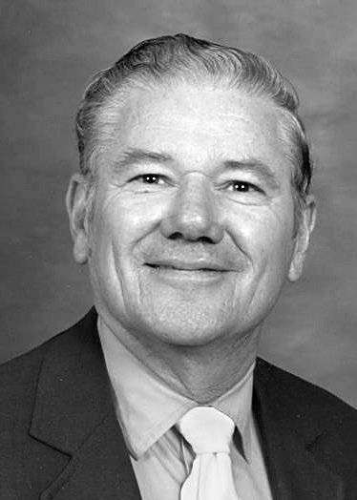
Martin Luther Church
Occupation: Program Manager, Retired

Age: 75 • Lives in: Acampo

I meet all qualifications spelled out in the U.S. Constitution. I am not a career professional politician with ties to special interests. My objective: return government to “By the people, for the people, and of the people” – not special interests.

Priorities:

• Reverse the current loss of U.S. control and independence in treaties, contracts, and immigration.

• Restore integrity in government by holding all elected and appointed officials accountable.

• Restore America’s trust by “keeping promises” made to veterans.
www.churchforsenate.com

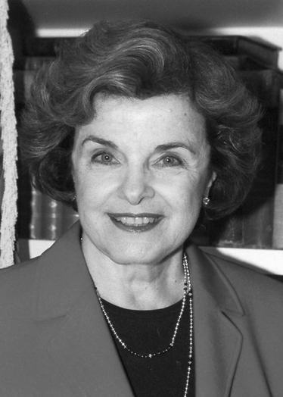
Dianne Feinstein

Occupation: United States Senator
Age: 72 • Lives in: San Francisco
Throughout my 13 years in the United States Senate, I have used an independent voice to collaborate with members on both sides of the aisle, to find common-sense solutions
to the problems facing California and the nation.

Priorities:
• Deal with global warming, which is the most serious environmental threat facing the planet.
• Provide federal help to curb gang violence.
• See that California can meet its future water needs.
www.dianne2006.com

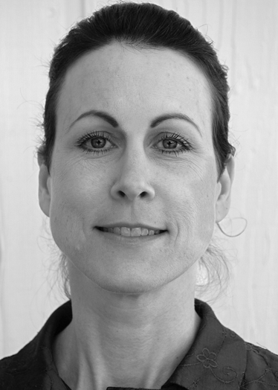
Colleen Fernald
Occupation: Mother/Artist/Entrepreneur
Age: 44 • Lives in: Occidental
As a leader in the sustainability movement, I’m dedicated to optimal personal and environmental well-being. My goals: define our mutual best interests, restore trust in government, adhere to the Constitution. Please inform all candidates on what gets your vote.

Priorities:
• Restore our military for defense, not optional conflict. Return the National Guard now; our troops next. Disallow nuclear weapons.
• Trustworthy voting system.
• Sustainable United States – promote the local economy, universal healthcare, environmental and climate protection.

Republican

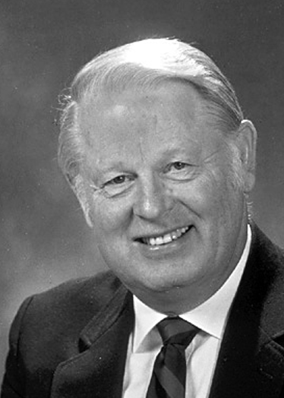
Richard “Dick” Mountjoy

Occupation: Businessman/Retired Senator

Age: 74 • Lives in: Monrovia

I’ve served in the City Council, State Assembly and State Senate. I will fight to protect our nation from the threat of terrorists, the illegal invasion and runaway government spending. I am a native Californian and will represent Californians.

Priorities:

• Border security now. Stop the illegal invasion – no amnesty for illegal aliens.

• Protect private property rights.

• Eliminate government waste and “pork-barrel” spending.

www.MountjoyforSenate.com

American Independent

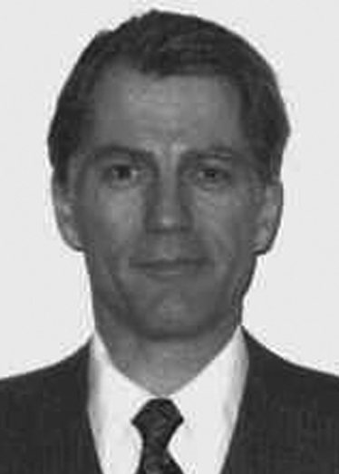
Don J. Grundmann

Occupation: Doctor of Chiropractic

Age: 54 • Lives in: San Leandro

I am a citizen who understands the biggest financial crimes being committed against our citizens and how to stop them. My policies will bring a wealth of jobs and prosperity to our state and nation.

Priorities:

• Expose and stop the criminal fraud of the Federal Reserve System and the I.R.S.

• Rebuild our industrial economy; stop the exportation of manufacturing jobs and develop energy self-sufficiency for the state and nation.

• Stop illegal immigration.

www.truthusa.org

Green

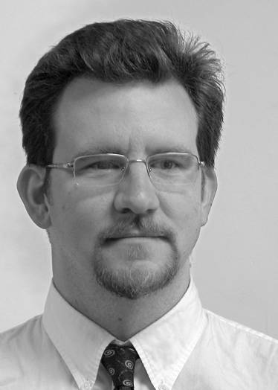
Todd Chretien

Occupation: Writer

Age: 36 • Lives in: Oakland

I’ve been a social justice activist for almost 20 years and a graduate of San Francisco State University. I am a union member, a writer with expertise in labor and civil rights history and organizing.

Priorities:

• Bring the U.S. troops home immediately from Iraq.

• Abolish the Patriot Act.

• Double the federal education budget.

www.Todd4Senate.org

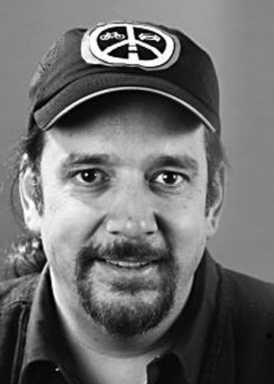
Tian Harter

Occupation: Grassroots Activist

Age: 47 • Lives in: Mountain View

I was Environmental Working Group Co-Coordinator for the GPCA for years. I got an MSEE before working in high tech, finishing at AOL. I care deeply about our future, and am working to make it better.

Priorities:

• More sustainable infrastructure: more bike lanes, better transit, and higher density cities.

• Work with nonprofit peace and justice lobbies for sustainability.

• New leadership; stop illegal wiretapping and the war, no accountability on 9/11 and Katrina.

www.tianharter.org

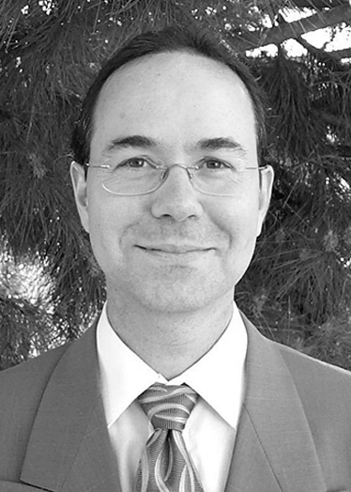
Kent P. Mesplay

Occupation: Air Quality Inspector

Age: 43 • Lives in: San Diego

I am educated in the sciences (Ph.D. Biomedical Engineering), experienced reading and interpreting legislation and enforcement code as a governmental regulator and as a presidential candidate. I have a multicultural background, including Native American ancestry.

Priorities:

• Create a sustainable economy; California will lead the nation and the world with wind and solar technology.

• Improve access and affordability of health care.

• Improve relations with Mexico.

www.mesplay.org

Libertarian

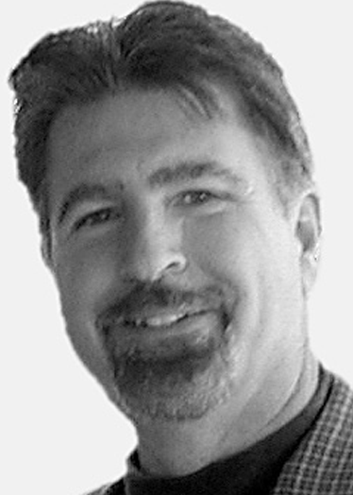
Michael S. Metti

Occupation: Self-Employed

Age: 53 • Lives in: San Diego

As a businessman both domestically and internationally, I have learned to successfully negotiate with private companies and government agencies. This qualification should serve Californians well in Washington where bringing home the bacon is the standard practice of our country’s politicians.

Priorities:

• Reduce government programs that serve only politicians and special interest groups.

• End the Patriot Act and clean up the mess at our borders.

• Bring our troops home.

Peace & Freedom

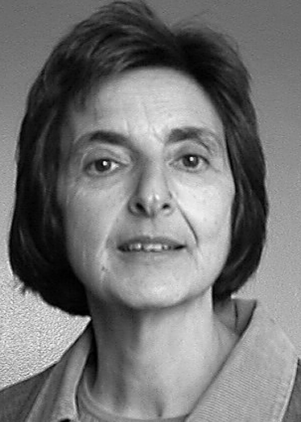
Marsha Feinland

Occupation: Retired Teacher

Age: 56 • Lives in: Berkeley

I have been a teacher and parent. I have been elected to help keep rents low in Berkeley. I believe ordinary working-class people can produce what we need and preserve the earth better than the greedy owners of corporations.

Priorities:

• Bring all our troops home now; stop making nuclear weapons.

• Provide for all human needs: decent income, housing, education and health care for everyone.

• Equal rights for all regardless of race, nationality or sexual orientation.

www.peaceandfreedom2006.org

Other Elected Offices
Lieutenant Governor
The next in line for Governor • Elected for 4 years
• Becomes Governor if the elected Governor dies, chooses to leave, or is removed from office
• Has a tie-breaking vote in the State Senate
• Heads up the Economic Development Commission
• Sits on the boards of the California university system

Candidate Liz Figueroa
Party Democrat
Occupation California State Senator

Residence Sunol

Candidate John Garamendi
Party Democrat
Occupation State Insurance Commissioner

Residence Sacramento

Candidate Jackie Speier
Party Democrat
Occupation California State Senator
Residence Hillsborough

Candidate Tony Farmer
Party Republican

Occupation Realtor

Residence Fresno

Candidate Tom McClintock
Party Republican

Occupation California State Senator

Residence Thousand Oaks

Candidate Jim King
Party American Independent

Occupation Real Estate Broker

Residence Riverside

Candidate Donna J. Warren

Party Green

Occupation Financial Manager/Author

Residence Los Angeles

Candidate Lynnette Shaw

Party Libertarian

Occupation Caregiver/Musician

Residence Fairfax

Candidate Stewart A. Alexander

Party Peace & Freedom

Occupation Automobile Sales Consultant

Residence Murrieta

Secretary of State
Elections chief and record keeper • Elected for 4 years
• Coordinates statewide elections; makes sure everything gets on the ballot properly
• Keeps records about campaign finances and lobbyists
• Issues official documents, like trademarks and filings for new corporations
• Runs the state archives to preserve California’s history with documents like the State Constitution

Candidate Debra Bowen

Party Democrat

Occupation California State Senator

Residence Marina Del Rey

Candidate Deborah V. Ortiz

Party Democrat

Occupation California State Senator

Residence Sacramento

Candidate Bruce McPherson

Party Republican

Occupation Appointed Secretary of State

Residence Santa Cruz

Candidate Glen McMillon, Jr.

Party American Independent

Occupation Small Business Owner

Residence Union City

Candidate Forrest Hill

Party Green

Occupation Financial Advisor

Residence Oakland

Candidate Gail K. Lightfoot

Party Libertarian

Occupation Retired Nurse

Residence Arroyo Grande

Candidate Margie Akin

Party Peace & Freedom

Occupation Archaeologist/Medical Anthropologist

Residence Riverside

Controller
The state bookkeeper • Elected for 4 years
• Keeps track of how the state’s money is spent
• Issues most checks from the state and manages collections of money due to the state
• Does audits and reviews of state agencies
• Reports on finances of state and local governments
• Works with many boards, including tax boards

Candidate John Chiang

Party Democrat

Occupation Member, State Board of Equalization

Residence West Hollywood

Candidate Joe Dunn

Party Democrat

Occupation California State Senator

Residence Santa Ana

Candidate Bret R. Davis

Party Republican

Occupation Businessman

Residence Foster City

Candidate David L. Harris

Party Republican

Occupation Businessman

Residence Discovery Bay

Candidate Abel Maldonado

Party Republican

Occupation Business Controller/Senator

Residence Santa Maria

Candidate Jim Stieringer

Party Republican

Occupation City Treasurer

Residence La Mesa

Candidate Tony Strickland

Party Republican

Occupation Taxpayer Organization President

Residence Moor Park

Candidate Warren Mark Campbell

Party American Independent

Occupation Minister

Residence Kaweah

Candidate Laura Wells

Party Green

Occupation Financial Systems Consultant

Residence Oakland

Candidate Donna Tello

Party Libertarian

Occupation Tax Accountant

Residence Poway

Candidate Elizabeth Cervantes Barron

Party Peace & Freedom

Occupation Retired Teacher

Residence San Jose
Treasurer
The state banker • Elected for 4 years
• Acts as the banker for the state and releases money to pay the state’s bills
• Manages the state’s investments of $60 billion
• Manages the sale of state bonds
• Chairs many boards related to state finances and investment

Candidate Bill Lockyer

Party Democrat

Occupation California Attorney General

Residence Hayward

Candidate Claude Parrish

Party Republican

Occupation Member, State Board of Equalization

Residence Rancho Palos Verdes

Candidate Keith S. Richman

Party Republican

Occupation Business Owner/Assembly member

Residence Northridge

Candidate E. Justin Noonan

Party American Independent

Occupation Computer Technician

Residence Marysville

Candidate Mehul M.Thakker

Party Green

Occupation Investment Advisor

Residence Oakland

Candidate Marian Smithson

Party Libertarian

Occupation City Treasurer/CPA

Residence West Covina

Candidate Gerald Sanders

Party Peace & Freedom

Occupation Longshoreman/Electrician

Residence Oakland

Attorney General
The law enforcement chief • Elected for 4 years
• Makes sure laws are enforced the same way across the state
• Serves as legal advisor to the Governor, Legislature and state agencies
• Manages the state Department of Justice
• Oversees sheriffs and district attorneys across the state

Candidate Jerry Brown

Party Democrat

Occupation Oakland Mayor/Attorney

Residence Oakland

Candidate Rocky Delgadillo

Party Democrat

Occupation Prosecutor/City Attorney

Residence North Hollywood

Candidate Chuck Poochigian

Party Republican

Occupation California State Senator/Attorney

Residence Fresno

Candidate Michael S. Wyman

Party Green

Occupation Attorney at law

Residence San Rafael

Candidate Kenneth A. Weissman

Party Libertarian

Occupation Attorney at law

Residence Beverly Hills

Candidate Jack Harrison

Party Peace & Freedom

Occupation Attorney/Rent Commissioner

Residence Berkeley

Insurance Commissioner
The insurance chief • Elected for 4 years
• Manages the state Department of Insurance
• Enforces laws that insurance companies must follow
• Helps the public with their questions and complaints about insurance

Candidate Cruz M. Bustamante

Party Democrat

Occupation California Lieutenant Governor

Residence Sacramento

Candidate John Kraft

Party Democrat

Occupation Insurance Healthcare Consultant

Residence South Pasadena

Candidate Steve Poizner

Party Republican

Occupation Businessman/Entrepreneur

Residence Los Gatos

Candidate Jay Earl Burden

Party American Independent

Occupation Student

Residence Marysville

Candidate Larry Cafiero

Party Green

Occupation Newspaper Editor

Residence Ben Lomond

Candidate Dale F. Ogden

Party Libertarian

Occupation Actuary/Insurance Consultant

Residence San Pedro

Candidate Tom Condit

Party Peace & Freedom

Occupation Writer

Residence Berkeley

Candidates are listed alphabetically within each party.
The parties are listed in the order of their size in California.

To link to these candidates’ websites, visit www.easyvoter.org. Or visit www.smartvoter.org for more detailed information about each candidate.

Superintendent of Public Instruction
The state schools chief • Elected for 4 years
• Manages the state Department of Education
• Provides leadership and assistance for 9,000 public schools in California
• Enforces state laws and rules about education
• Acts as a spokesperson for public education

This is a nonpartisan office, so candidates’ parties are not shown on the ballot. Someone must get more than half of the votes to win this office. If no candidate wins in the June election, the two with the most votes will run against each other in the November election. Each candidate sent us a short statement and their priorities.

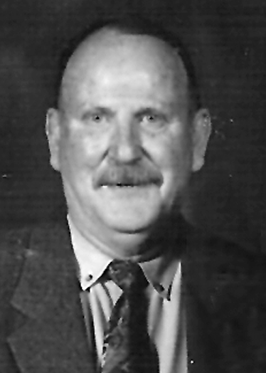
Daniel L. Bunting

Occupation: Retired School Superintendent

Age: 74 • Lives in: Cloverdale
I have 50 years experience in education as a teacher (K-8), principal, programs project writer, District Superintendent, School Board Member (currently in Cloverdale Unified School District). I have also served as a school bus driver, and night custodian.

Priorities:
• To be highly visible to all school districts, large and small.
• To seek better direction in teaching, through how children learn, and how they learn best.
• Advise the Legislature regarding feasibility of legislation affecting schools.

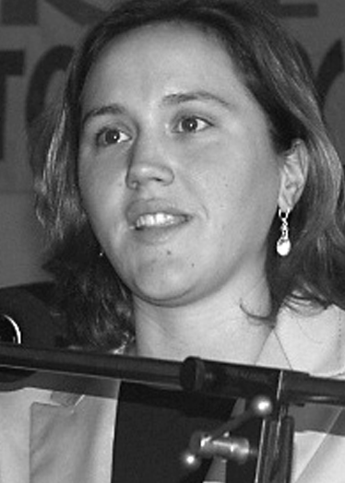
Sarah L. Knopp
Occupation: Teacher

Age: 28 • Lives in: San Pedro
As a seventh-year teacher in South Central L.A., I know what is needed to make real change. I’ve been a community organizer for ten years and am experienced at organizing people to advocate for changes that they want.

Priorities:
• Lower class size immediately.
• Advocate against the testing and accountability craze brought in by No Child Left Behind.
• Work toward desegregation of our schools. Segregation is worse than any time since 1968.
www.sarah4super.org

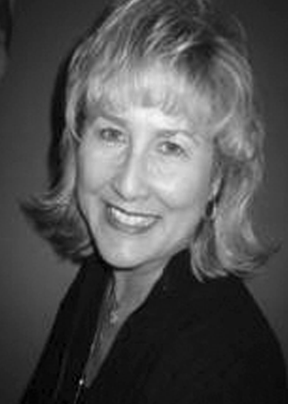
Diane A. Lenning
Occupation: Educator/Author/Businessowner

Age: 59 • Lives in: Huntington Beach

I am a national education leader and former chair Republican Educators Caucus; an advocate for empowerment through education. U.S. Senatorial Medal of Freedom Award: writing, speaking, lobbying; national, state, local. Teacher for thirty years, Broad National Award-winning school district.

Priorities:

• Safe schools provide the learning environment for student success.

• Control through local school boards supports community collaboration, academic progress, tutoring programs.

• Empowerment of education reduces drop-out rate, assures proficiency, prepares for work force, achieves American dream.

www.DianeLenning.com

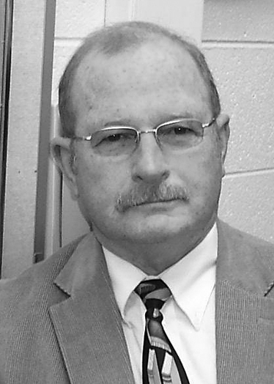
Grant McMicken

Occupation: Mathematics Teacher

Age: 60 • Lives in: El Dorado Hills

I have 25 years teaching experience and ten years experience as a computer programmer and consultant for federal, state, and private sector businesses. I know the problems confronting our children and teachers. I have solutions for many of the problems.

Priorities:

• Establish academic oriented, career-training programs in high schools.

• Establish a searchable database of standards-based lesson plans accessible to teachers and parents.

• Require algebra or applied/business mathematics courses for HS graduation.

www.grant-us-ed.com

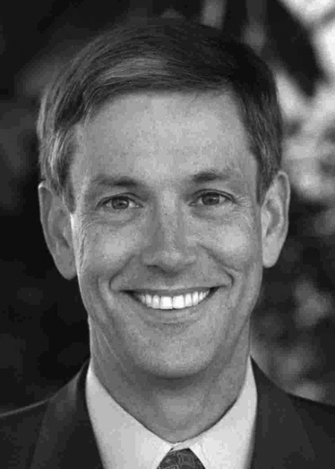
Jack O’Connell

Occupation: State Superintendent/Teacher

Age: 54 • Lives in: San Luis Obispo

I have worked in education for over 30 years as a parent, teacher, school board member, state legislator and now State Superintendent. In that time, I reduced class sizes, increased school accountability and advocated for additional resources for our kids.

Priorities:

• Advocate for additional funding for our schools.

• Make school a more relevant experience and ensure our graduates are better prepared

to join the workforce or succeed in higher education.

• Recruit and retain new teachers.

www.oconnell2006.org

Propositions
In this election, California voters are being asked to vote YES or NO on two propositions that would change state laws. Proposition 81 is a bond measure that was placed on the ballot by the State Legislature. Proposition 82 is an “initiative,” which means that voter signatures were gathered to place it on the ballot.
These are short descriptions of each proposition. For more information, read the Voter Information Guide mailed to each voter. The “arguments” for and against are the opinions of people who support and oppose the propositions.

PROP 81: Library Bonds
The way it is now: Usually, local governments pay for the cost of operating and building local libraries. Sometimes, state funds are used as well. For example, in the year 2000, voters approved $350 million in bonds for library building projects. That money was used for 45 projects. Another 60 projects applied but have not been funded.
What Prop 81 would do:
Allow the state to sell $600 million in bonds for building, renovating or expanding public libraries to serve more Californians. This money could not be spent on books and materials or on ongoing library operating costs. To get some of this state bond money, a local government would have to contribute 35% of the project’s costs.
Effect on government spending:
New state spending of about $1.2 billion to pay off $600 million in bonds and $570 million in interest over thirty years. This would cost the state about $40 million per year. Local governments would also spend about $320 million of their own funds.
Arguments for:
• Libraries provide critical community services such as literacy programs, free access to computers and the Internet, and safe places for children to do homework.
• We need to continue investing in our libraries – building new libraries and renovating old ones – to keep up with the state’s growth.
www.yesforlibraries.com
Arguments against:
• Paying for libraries with borrowed bond money just passes the costs on to our children.
• The Governor and Legislature should make budget cuts to free up enough money to pay for library projects without having to borrow more money.
www.protecttaxpayers.com

PROP 82: Tax for Public Preschool
The way it is now: About 62% of California children attend some kind of group preschool or childcare program before going to kindergarten. About half are in public programs such as Head Start or state-funded preschool or childcare. There is a lot of variation in what preschool programs provide, how much they focus on school readiness and teacher training.
What Prop 82 would do:
Change the State Constitution to offer all four-year
old children in California the right to one year of free preschool starting in 2010. The state would run the program through County Offices of Education, using existing and new preschools. Families would have a choice of free preschools, paying for private preschool or no preschool.
Public preschool would be funded by an additional 1.7% income tax on individuals earning over $400,000 and married couples earning over $800,000. The state would set standards for what is taught in preschool programs. Teachers would have to meet higher educational requirements and would be paid more than current preschool teachers.
Effect on government spending:
The new income tax is expected to rise about
$2 billion per year. This money could only be
spent on the public preschool program. In the first
10 years, some of the money would be used to build preschool buildings and train teachers.
Arguments for:
• Prop 82 will give all children access to high quality preschool and ensure that there are well-trained teachers at all preschools.
• Studies show that investing in preschool increases students’ success at reading and learning, and makes them less likely to drop out of school.
www.YesOn82.com
Arguments against:
• California has serious budget problems.
This program would lock in free preschool for families that can already afford it.
• To improve student learning, we should invest in K-12 schools instead of building a whole new preschool bureaucracy.
www.NoProp82.org

What are bonds?
Bonds are a way for the government to borrow money. When the government sells a bond, the government is promising to pay back the money plus interest. The money to pay back bonds comes from state income taxes and sales taxes.

Easy Voter Guide

California Primary Election
Tuesday, June 6, 2006

Voting is as easy as 1-2-3!
1. SIGN UP TO VOTE
Sign up to vote
• To vote in the June 6 election, you must register (sign up) to vote by May 22. It’s free!
• To get a voter registration form, you can:
- Call 1-800-345-8683 to have a form sent to you.
- Pick up a form at the library, post office, DMV, or
other public places.
- Visit www.ss.ca.gov and click on “Register to Vote.”
• When you fill out the form, be sure to include your identification information. This is a new law.
• You must fill out a new voter registration form if you move to a new address, change your name, or want to change your political party.

2. Get ready to vote
• To learn about the election, registered voters get two booklets in the mail:
- The Sample Ballot lists all of the candidates and measures that will be on your ballot.
- The Voter Information Guide covers information just about the statewide propositions and some of the candidates.
• You don’t have to vote on everything on your ballot. Choose the things that matter to you and learn more about them.

3. VOTE!
• Vote in person: Look at the mailing label on your Sample Ballot for where to go. Your polling place will be open from 7 a.m. to 8 p.m. Some counties also have convenient places where you can vote before Election Day.
• Vote by mail:
- The form to request an “absentee ballot” comes with your Sample Ballot. Fill out the form and mail it in to arrive at your county elections office by May 30.
- If you want to be able to vote by mail in every election, you can check the box for “Permanent Absentee Voter” on your absentee ballot request form.
- When your absentee ballot comes in the mail, fill it out and mail it back in time to arrive by Election Day. Or, drop it off at any polling place in your county by 8 p.m. on Election Day.

Visit www.easyvoter.org, www.ss.ca.gov and www.smartvoter.org
for more information about how to vote and about this election.

[Credits]

The nonpartisan Easy Voter Guide is a collaboration of the League of Women Voters of California Education Fund, the California Secretary of State’s Office and California State Library, with additional support from The James Irvine Foundation and the San Francisco Foundation. This guide has been published for every statewide election in California since 1994.
Many people help to assemble and distribute this guide. Partners include: the League of Women Voters of California Education Fund – Jacqueline Jacobberger, Robbie Davis, Jill Kaiser Newcom and Carol Souza Cole; the California Secretary of State’s Office – Caren Daniels-Meade and
John Mott-Smith; the California State Library – Susan Hildreth and Jacquie Brinkley; and Kathy Hassan at the Center for Asian Americans United for Self Empowerment (CAUSE). Special thanks to the team at the Legislative Analyst’s Office. Literacy consultants: Constance Mack, Patricia Rosado and Resonja Willoughby.
The Easy Voter Guide is produced by Common Knowledge: Susan S. Clark, Antonia Hollander, Brenda Bonhomme, Mony Flores-Bauer. Proposition review by Linda R. Davis. Graphic design and production: Gino Squadrito of Laser.Com. Cover design: Leah Prahm. Translators: Victor Reyes, Claire Liu, Jacki J. Noh, and Dzung Pham. The www.easyvoter.org website is maintained by Literacyworks.
Supported in part by the U.S. Institute of Museum and Library Services under the provisions of the Library Services and Technology Act, administered in California by the State Librarian.

